**Conversation Guide: Digital Health Modernization Discovery Research**

**Key**

* Numbers correspond to sections of the discussion guide
* Moderator questions are in bold
* Moderator observations are in italics
* Redacted information (mainly PII) is in [brackets]
* Unless specifically denoted by "quotation marks," participants' utterances have been paraphrased due to transcription cost constraints, with the intention of capturing truthiness

**Introduction (2 minutes)**

*Start recording.*

* **I have started recording**. **I'd like to confirm: Are you comfortable if I record my screen and the audio as we talk today?** Yes. I am fine with it.

**Background (5 minutes)**

To get started, I’d like to get a little background information about you, and your experience with the VA.

1. **Can you tell me a little bit about yourself?**  I am a Marine veteran of 26 years and retired out of the reserves from 2008 and have been a gray area reservist waiting retirement pay on the 60th birth last April. Marine Veteran of 26 years.
2. **So you officially retired in 2008?** 2008 from the reserves, because it is a reserve veteran the retirement pay doesn’t start until you turn 60 so I have been drawing month retirement since this April.
3. **Do you have other things that you receive through the VA — other than retirement pay?** I have received a VA home loan 27 years ago and I sold it earlier this summer, it was a va home loan and I was a first time homeowner and it was and extremely helpful benefit to me and my family [in 93]. Not for me personally but my father was a veteran receiving healthcare form the VA in DV so I helped with his appointments so "I know a bit about the VA healthcare system due to advocating on his behalf." I have retired to enroll in the past I have no eligibility or in the lowest level so "I don't think I rate healthcare through the VHA due to my personal situation."
4. **Experience of trying to enroll:** I went online and tried to enroll, I answered the questions it was streamline and efficient. It was some time ago I think "the final adjudication was that I was not eligible or that I was in one of the lowest of the 8 priority groups for healthcare." I have existing healthcare through my civilian healthcare and have for the past 27 years so I haven’t pursued it further. "I just assume I am not eligible for any true VA health care." I don’t know if it will change and I need to look into it more in the future. [I am about to retire and] will have Tricare starting next Friday...we selected a physician. Tricare will be what my wife and I use, moving forward.
5. **Civilian healthcare, employer base:** Yes I still am on my civilian insurance until I retire, and then I will be on Tricare the next day.
6. **Do you remember how long ago you went online to enroll**: It has been a good 8-10 years. I was closer to my retire from the Marine Corps back in 2008.
7. **How did you first learn about health care or other benefits available through the VA?** Mainly just researching online at **[va.gov](http://va.gov)**. I'm a researcher like yourself; I've done VA contract work and we do qualitative and quantitative surveys and studies as well. Just being a veteran, I am very aware of the programs and benefits that the VA offers to qualified, eligible veterans. The only one I've taken advantage of is the VA home loan.

*This is interesting. Very confident that he understands benefits eligibility and also states that he is ineligible for health care repeatedly, which is not true.*

1. **Do you have any family members who you claim as dependents**? Just my wife and me. She is my spouse; I don’t know what you mean about dependent. I am her sponsor of military benefits and as a family member I believe that what the military calls a dependent.

4.a. **Do you manage any of your personal benefits online**? Other than the VA home loan that is now passed. I don’t. I have nothing or benefits I currently take advantage of it. I had paid it off prior to selling it so I worked with a third party veteran service organization that helped get the eligibility reinstated [for a home loan]. I think it was a financial institution that provides services with the VA home loan but that was the last time I would have done that.

**When helping your father with his VA helath care, were you using online tools?** I signed him up for HealtheVet, which is what I recall that account being. He was an older gentlemen so he didn’t have the skills to do it online but I signed him up using his personal information and SSN to establish an account to help advocate on his behalf and manage prescriptions and appointments. I cannot remember all of the details available.

*I wonder how many MHV accounts are single user self-managed vs single user other-managed vs multiuser.*

**Do you remember how you found it and it was an option**: I think I may have came across a poster in the VA Medical Center when going to an appointment, I think I recall advertising and marketing material there that mentioned the system and decided to sign him up to see what it offered.

**For your personal healthcare outside of the VA, do you use any online tools?** I have a HSA through payroll deduction at my civilian employer. My plan is HDHP through [insurer]. Whenever I buy prescriptions or what have you, I manage all that through my online account. Either using my debit card or paying bills through my account balance [online]. I wish I was a little better at it.

**Is that separate from scheduling appointment or refill prescription?** My healthcare account has another portal online where I would see my prescriptions and doctor visits, and any physician notes that follow visits in another portal altogether. That's local to me, it's where my primary care physician is located and where I receive services. I have my own login account, it's a civilian account obviously.

**How do you like the experience of that online portal?** I liked it a lot. I haven't had a lot of healthcare needs but I had a [redacted medical issue] so I had a [redacted appointments and procedures]. Everything has managed through that portal. I saw the lab reports, it was all on that portal, and I sent a couple questions to my primary care physician at the VA for some results that were posted on that portal. I found it easy to type out questions... it made it easy to follow up and help with my care overall. It's easier to type questions rather than talking to them on the phone.

*Sounds like he used MHV.*

1. **Do you use any mobile apps to manage your health?** No.
2. **What do you use for a device to manage these types of things**: I don’t normally access that patient portal on the phone I don’t know if I have their app. I normally do it on my laptop or PC at my residence. I do a lot of my banking on an app to manage my accounts and paying bills. I have other apps to track the weather and exercise. From health care perspective, I don’t.

**Mental model of health at the VA (20 minutes)**

Now I’d like to hear about your experience transitioning from the military to the VA. **(10 minutes)**

1. **How did you learn about the health care available to you through the VA, and what was the process of applying for and accessing those benefits?** Mainly just researching online on va.gov or through the benefits. I am a researcher like you, we have done va research and do qualitative and quantitative research. Just as a veteran I am aware of the benefits for qualified veterans. I have only used the VA home loan though.
2. **How did you learn about your retirement**: as I was still in I knew about DFAS mypay website, I was tracking paystubs and my monthly pay through that application. When I retired and went in the grey area reserve status. I don’t know if my account was deactivated or just didn’t need it. But when I became eligible at age 60 for military pay, I was provided information that allowed me to reactivate the account. I get an email each month when the paystub is ready. I mange all of that online.

*Ongoing communication from some other org, probably the DoD or the Corps itself, is giving vets information that heavily influences awareness and usage of VA services. This is a "marketing" opportunity to make sure vets are aware of what they can have and how to have it. Would be great to get hold of some of those comms to see what is talked about, how and where vets are directed to, to find it on the VA side.*

1. **Notified to sign up, how**: I would have as a Marine retiree, I get my service through the Marine Corps retiree branch in Quantico, VA that manages the HR types of issues. I spoke with them and they would have contacted me 2-3 months prior to becoming eligible at age 60 notifying me what they needed. I remember getting hard copy communication to establish those account and what was needed in order to get a military ID, and for that retirement pay to start, back in the spring. Marine Corps headquarters in Quantico HR services.

**Did you receive anything from the VA regarding retirement?**

1. I remember getting a packet explaining the gneral benefits that may be eligible to me as a retiree or veteran. It is stored away somewhere and I don’t think I could find it right now but I remember the general benefits to include the education benefits such as VocRehab, GI bill, home loan, and healthcare. "In all honestly, if I were looking for that type of information I would just go online." It is nice to send it out in a postal communication, and if there is a URL or weblink to get you to the appropriate place, I that that is extremely helpful. I was in a brief with VBA that were telling me about a program called Solid Start that they started last December, and they are calling and contacting veterans after separate at 90-180 and 1 years prior to separation.They call that the solid start program. But it's in VBA. What I learned about it; it is a tremendous benefit in that counselors are calling at those times just to talk to the veteran and answer questions about benefits that are available to them. There are counselors that call at those times at separation to answer questions about the VA benefits.
2. **If you received that, would you have done anything differently after your service?** No I used the services I needed and as a veteran I have less needs than others due to having healthcare under a private healthcare, I didn’t need the GI bill as I used it while on active duty then there are tuition assistance for veterans. I have only used the VA home loan and compensation.
3. **Thinking about others needing other type of assistance, what are your thoughts of not needing**: Like the GI bill, education, rehabilitation programs and job assistance. I am not in a situation that I would need to take advantage of that program or support but obviously other do. I am an old Marine; I know a lot of those benefits are more for the younger veterans as they have spent a term enlisted, only four or five years. But as an officer 20+ years in I just don’t have a need of those services.
4. **DFAS and MY pay**: It is the military pay system that tracks our retirement pay. DFAS is the defense financial accounting service. Active duty and reservists and retirees. They provide the financial assistance and that’s where we get paid.
5. **Anything you need to do on a regular basis for retirement pay**: Just when they send me an email each month with the paystub. That is a few days prior and it is the same month after month. It is pretty established. I monitor it when we get the email to make sure the correct amount hit my bank. I have been there recently to update our new email and address. It is helpful and works.
6. **You verse your dads portal**: I didn’t get into the details with his as I am with my personal account. I monitored his and not everything he was getting as medicine or for appointments weren’t all in there. I didn’t get much into the details for him because I wasn’t his primary caregiver. My aunt, my dad’s sister in law did a lot of his care for appointments and communications when he was in the hospital or having his checkups. It was mostly done outside of the portal. We did sign up because we were curious but not used a lot once signed up.
7. **Myhealthevet look familiar**: yes, I was in there a week or two weeks ago becau se I had it on my list of bookmarks and I was seeing if I needed to update my emails. I visited it I recognize the logo at the top left, myhealthevet, and I poked around in here to see what's in there. There wasn’t many details in there, I set it up for my dad so I used his information to setup and login. It seems clean and I am impressed. The va has done a lot of work to improve the information provided the veterans and it covers the main kinds of things I see in my civilian portal.
8. **[Do you have an account other than the one you set up for your father]?**: No it was the initial account I set up for him.
9. **VA.gov, have you seen the website**: I cannot say I have seen this website before.
10. **Tell me about the health care you receive through the VA.** Not saying I haven’t been there before, but it is not ringing a bell. There are a lot of VA sites for benefits, you have the VSO with links, I am in the American legion so I can get the benefits through my American legion account as well.
11. **How would you explain a “disability rating” to a new Veteran?** I am, because I have a brother in law with a rating and receives a medical monthly payment due to his disability rating.
12. **How would you describe it to a new veteran?** The process requires that the veteran seeking the payments go through an exam with doctors in the VA or — I don't know if civilian doctors do it. After the exam and some kind of adjudication they decide on the rating, it goes from 10 to 100 percent at 10% intervals. Then based on the rating — and I don't know if it's tied to your pay grade or rank — it leads to a monthly payment for that disability. From my own research, there is a threshold to even receive a pension so I don’t know if —anyone under 30 or 80 or 100 percent. I think they are linked to different monetary payments from the VA. I think individuals at 100 are qualified for additional VA benefits.
13. **What are the additional benefits**: Extra programs or services offered by VA. At least at 100 percent they payment is higher than someone at a lower level. There are some organizations, Veteran Service Organizations, that tie their benefits to the rating. I just saw an announcement that any wounded veteran, the nation parks have now offered free admission to any wounded veteran, so I assume if you are a purple heart you do not need to pay. It is tied into a disability benefits due to an injury or illness or being wounded and received a purple heart or disability rating.
14. **You mentioned if the disability rating is tied to your pay grade or rank; do you mean depending if you got paid more or had a higher rank, that might affect disability compensation?** Yes, I was thinking of that because I am relating it to the allowances received while on active duty. Housing was paid to paygrade and geographic location. Maybe only the disability rating is what is required. As sometimes is the case with benefits and programs, it may be tied to other demographics. I just don't know how that disability rating works.
15. **In your mind, is there a relationship between “disability” and “health care” when it comes to the VA?** Obviously, I would think there's maybe other programs that are eligible to the disabled veteran that may not be eligible to a typical veteran that's receiving healthcare through the VA system. There may be a relationship that exists.
16. **Have you ever filed a disability claim**: I have not. I have not considered it because I have no injury or illness [acquired in the line of duty] that would require me to seek that assistance.
17. **If you were to describe MHV to a new veteran, how would you describe it?** I would tell them it's an online account, a personal account, that would allow a veteran to manage their healthcare — and would track thigns such as appointments, prescriptions and notes following doctor visitors or lab work. Similar to what I've used recently in my civilian portal. It's beneficial to have it in one spot instead of creating your own system outside of an electronic portal. The big discriminator is, not everyone has computer access [or] the skills to take advantage of those. There are older veterans... that do a lot of note-taking and... don't take advantage of the online system. I would think a younger veteran... is more inclined to use a portal like myhealthevet. If anyone has needs beyond a physical or whatever, it would be extremely healthy as long as they know it exists.
18. When it comes to your health care, what is the most important thing you need from the VA?

Now I’d like to ask you how you manage information and tasks related to your health care. For each one, talk me through the steps you’d take. If there is something that you go online to complete, I may ask you to share your screen so I can see what you would do. **(10 minutes)**

**Tasks** Moderator should prompt about device usage if participant mentions digital tools or resources.

* How would you reach out to your VA care team if you had a question?
* How would you refill a prescription you have with the VA?
* (If applicable) How would you go about checking the date of an upcoming medical exam you have for a disability claim?
* How about an appointment for a yearly check up with your VA care team?
* (If applicable) Or a private provider (dentist, optometrist) outside the VA?
* How would you pay a VA health care bill, such as a copay?
* How would you request reimbursement from the VA for traveling to your health care appointments?
* How would you update the dependents on your VA benefits?
* How would you make updates to your health care benefits?

**Branding and trust (5 minutes)**

Now I’d like to ask for your thoughts on My HealtheVet. (Confirm that participant has used My HealtheVet previously. If not, amend questions below to capture their first impressions while looking at a logged in account.)

1. **On a scale from 1-5, with 1 being very dissatisfied, and 5 being very satisfied, how satisfied are you with My HealtheVet**: My use was linked by based on the areas and the presentation it is a 4 or 5. The only reason I don’t say 5 is because I don’t know if it has everything I need as a veteran patient. The access to is and the different areas set up look like it would be extremely helpful.

3.a. What makes you rate it a [their rating]? What would make it better?

1. **On a scale from 1-5, with 1 being very low, and 5 being very high, how would you rate your trust in My HealtheVet?** I would say 4 and I don’t say 5 because it is just like all portals. It is only as good as the information being fed into it. My personal portal there was stuff missing and "if I get in there I want it all to be completely exhaustive and comprehensive"> With my civilian portal I was a bit frustrated when information was not there from some other mechanism or mode, but should have been placed in there. As long as the VA and healthcare providers feed the system, and everything is in there that the veteran would need, I think it would be a great resource.
2. **Having accurate and complete information is what you're dedscribing**: Mostly information in there is accurate, it's just a matter of completeness. No one is going to go in there and put any kind of erroneous information. I often find, not only in healthcare portals but in other things, it's not completely comprehensive, and it's not complete.

4.a. What makes you rate it a [their rating]? What would make it better?

1. If you have a question about your MHV account or something isn’t working, what do you do?
2. Have you ever been in touch with a My HealtheVet Coordinator?
3. How does My HealtheVet compare with other online health tools you’ve used?

**My HealtheVet patient portal (15 minutes)(personal portal)**

Let's take a look at My HealtheVet together.

Moderator will ask participant to share screen if not already, or show logged in My HealtheVet account. **(5 minutes)**

1. I have the bookmarks toolbar at the top and I have this mychart [bookmark] which gets me into the portal I use. I am seen at [name of healthcare system redacted]. On the right side it remembers my username and password. At the top are the visits, messages, test results, and medication that are part of my personal healthcare. As I click on test results you can see the list, this is where they did my [redacted procedure] and the bottom is my [redacted procedure]. Those dates and who ordered the lab with the dates in my chart. That is part of that portion. Medications would be the list of current medication I am prescribed. I don’t have a lot but I take a daily aspirin. Then visits and messages are self-explanatory.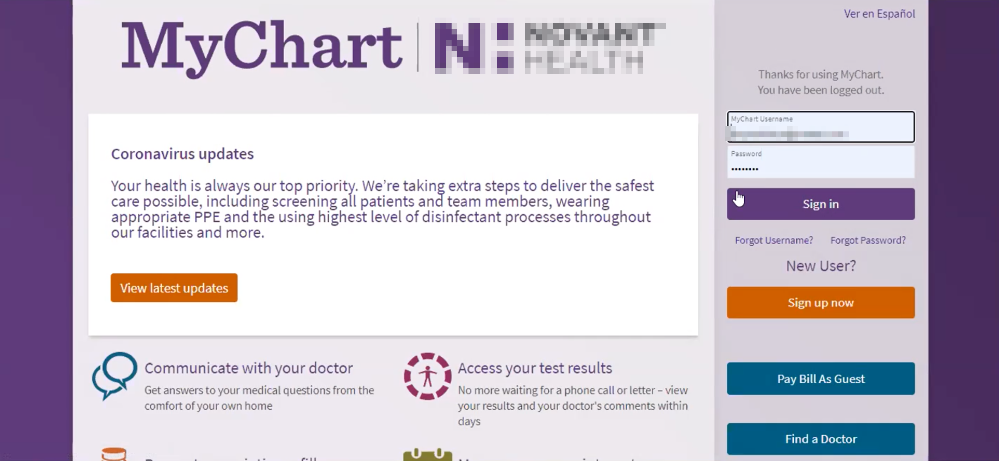

*Browser autofill had his credentials.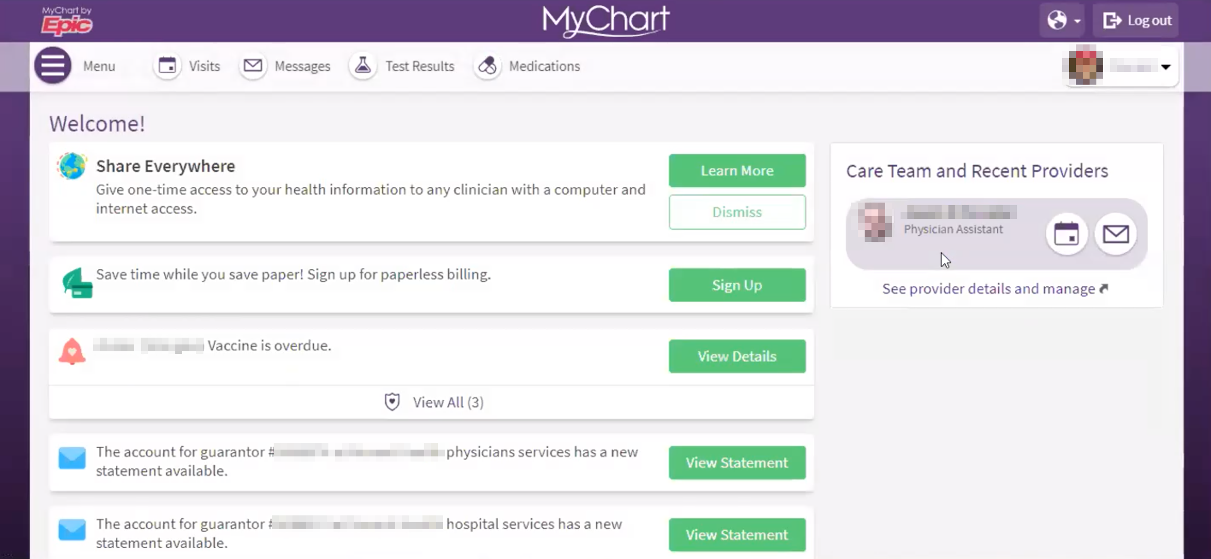*

1. **About the medication, is that something you don’t have a prescription**: Not besides the [redacted medication]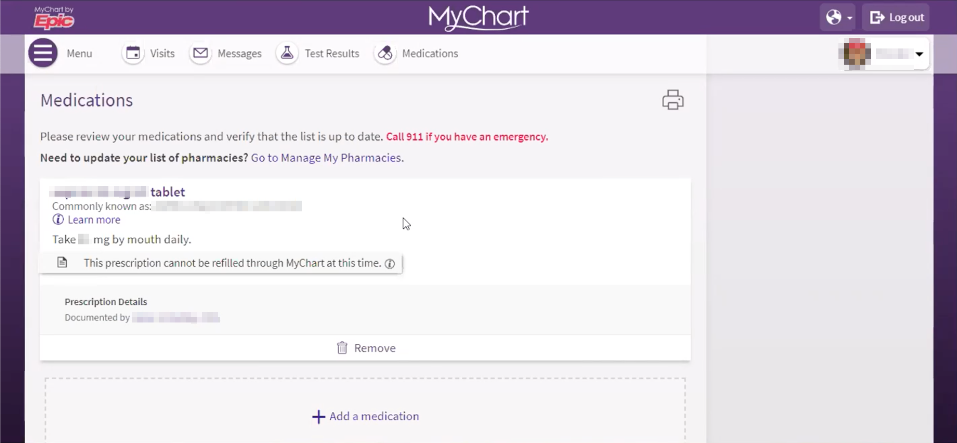
2. Records or prescription: that is what they recommended for me and that was when I told them that I take [redacted] that was recommended years ago and I maintain that. I had been on other prescriptions the past 34 months but they removed it as I went off of them. I don’t think it captures historical but is my current snapshot of my prescriptions. In the past when I was on other ones for my disk I saw perceptions that are no longer here.
3. **Difference between something prescribed vs something you document**: I don’t know if I recall that. You would think they would make a delineation between what you choose vs something that is prescribed. I would assume so because I am impressed by the portal in general.
4. The other couple tabs I was gonna mention — the visits one is extremely helpful for understanding history. It shows the doctors visits, and for when I went in for a lab, my [mentions a few redacted tests / procedures] and there is more in the visit summary that you click on for that visit, that talks about the result of the visit and so forth. The reading of my [diagnostic test redacted] it is extremely helpful because I can see exactly the technicians' interpretation of the [redacted] and then they use their fancy terms, and that leads to questions, that I can follow up to my physician or PA to get their interpretation as a follow-up. I did that with other blood work as well. It is more historical in nature and keep past appointments there

*Participant called attention to how useful visits was, without prompting. Really wanted us to hear / understand this. Then did the same for messages.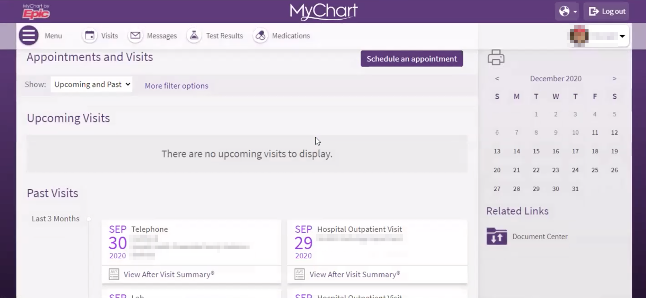*

1. **Message tab**: it allows me to send a message to anyone on my care team in this practice, and they would have sent message to me. I know my provider after they received the result from the [redacted diagnostic] they put notes there as well. It is a nice communication portal and ties the work in to an overall plan.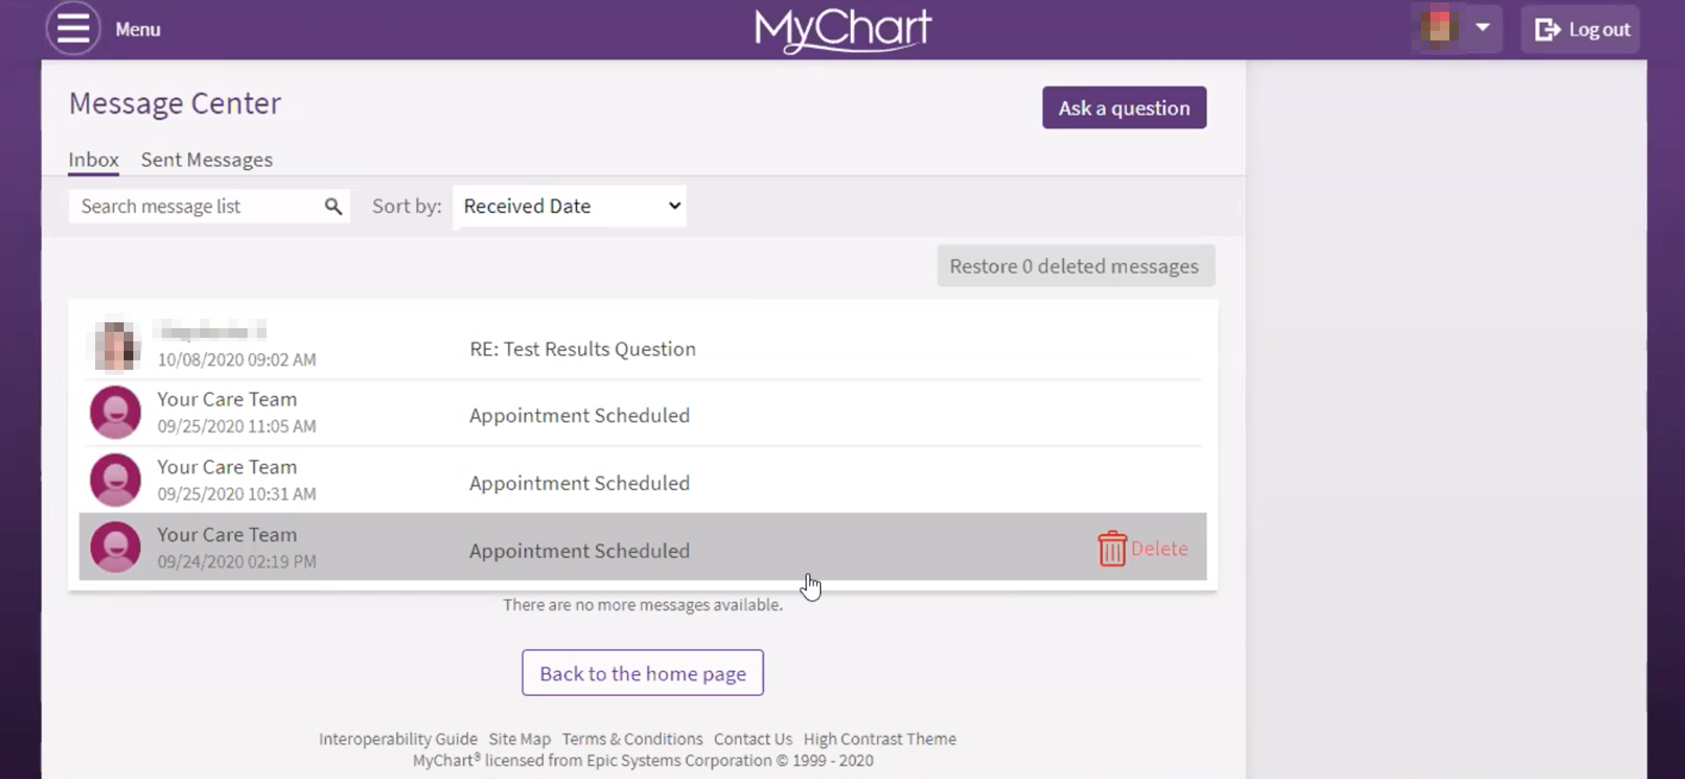

*This person understands they are communicating with a practice rather than a person. It's their explicit mental model.*

**Menu button**: visits, message, test result. Medication at the top is just short cuts.

**Would you expect to see anything related to your health care bill on this portal**? You know what, I receive hard copy bills but that I receive emails from them stating that I have an amount due. I should know this; it may be in here. Here's the billing area at the bottom. I guess this is tied into the emails I receive and shows the amounts due and so forth. So it is tied to billing.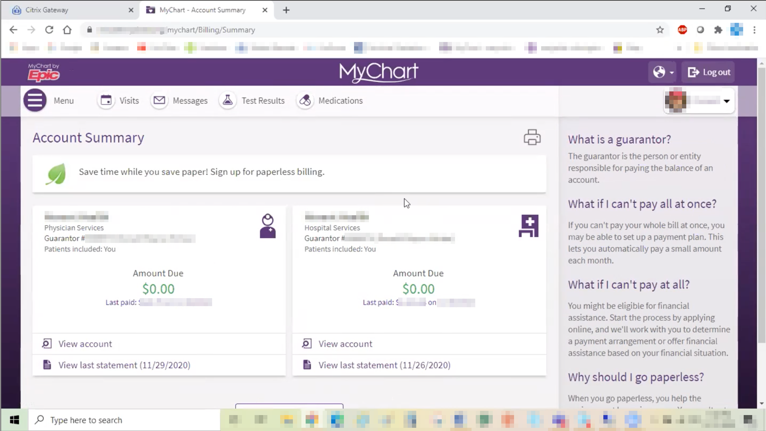

**Emails received from my chart or provider**: I think they do come through this [practice name redacted] mychart. It's a nice, integrated system. I normally wait. I receive the emails telling me the balance, but I typically wait for the hard copy in the mail to make sure that it has run its course and my healthcare and adjudicated the benefits and has paid what they are going to pay. So when I get a paper bill I sit down at my [name of insurer redacted HSA] portal, and then I pay that bill to [practice name redacted] through my HSA. The amount, address, and provider and it saves the accounts so I can select the provider and make the payments in that portal.

**In this entire portal, what is used the most**: I think the test results and visits. If I have bloodwork done or an x-ray done, I want to know the results of those as soon as possible. That's extremely helpful. I like the visit portion as well because it's chronological and maintains that history for me. I still have a spreadsheet with my own history of my own visits because I like to do that as well, but I like the tracking visits tab also. I only used the message tab a couple times to my care team, but it's extremely convenient not to have to try to call the office and find them because they are making rounds, so if I send a message they may see it and I will have the response the next day.

*Wonder if we can get the spreadsheet? Probably overkill.*

**Visits show history and medication shows current state, do you have historical for medications**: It may be in here but it doesn’t look it. This looks like current prescriptions. I think it would be helpful to see the history in the medications as well, as long as it is detailed enough to know one is a past and one is a current, to help the veteran think about my current list versus what was in the past. I haven’t had many medications so it might not be important for me as others, but my dad was on 7 or 8 prescriptions in his latter years. I just think it would help manage it. Especially if someone is serving as a caregiver for an older veteran, that medication would be extremely important. If you are being seen by a new specialist or have a new condition, those questions come up during discussions: Have you ever taken this, or been on that prescription? Then the provider can have a complete history before they make a diagnoses or provide a new prescription.

**Anything here that is missing or want here**: I don’t think so. Between these major ones here and the other options, I think it is pretty comprehensive. I don’t know if it allows me to customize, I think it pulls the tabs out and places them here other veterans let you customize what you sue the most. I don’t know if I had a choice here. I found this to be extremely helpful when I was going through my [redacted medical issue] several months ago. It was really the first time I used a portal for my health care. They look lovely, but it is only based on the information that is provided, you have got to feed the beast. There is time required of medical staff. To get results and upload the information, that is the intention to have it all in one place for the benefit of the patient and them. It can get frustrating if you know there are medications and visits that are not there. Then you lose trust and faith in a portal like this. Because you know you had a visit. Five of six visits are there. Why isn't this other one? It gets you questioning the accuracy or validity of the website.

*For comment about customization, participant moused over MyChart's main nav and I believe was making the point that MHV has similar main calls to action (meds, visits, messages) in places of prominence -- just with a different UI.*

**Thank you and closing (2 minutes)**

Feedback: I don’t! I hope my time was helpful so that systems can be improved to provide better care to our veterans.

**Well we really appreciate you taking the time to share your thoughts with us today. Your feedback is so helpful to us as we continue to work on the site and make sure it really works for Veterans.**

Lastly, do you know any other Veterans, caregivers, or service members who might be willing to participate in a future user research session? If Yes: Thank you! I'll have our team send you an email with a little blurb that you can pass along.

Great, well thank you so much again, and enjoy the rest of your day!